Exercise #6
- Order all employees on the basic of the salary they draw.
SELECT * FROM employee_data ORDER BY salary;
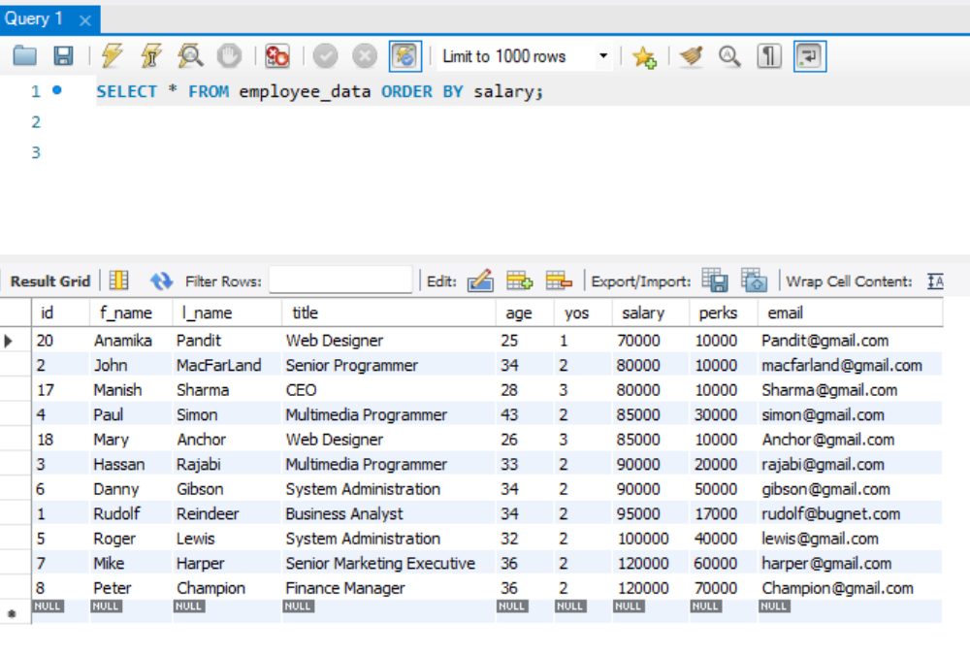
- List all employees in descending order of their years of service.
SELECT * FROM employee_data ORDER BY yos DESC;
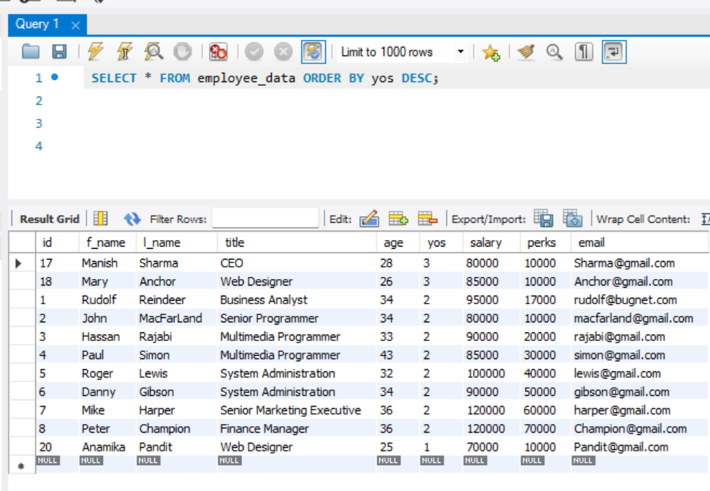

- What does the following statement display?
SELECT emp_id, l_name, title, age from employee_data ORDER By title DESC, age ASC;
-- I used ‘id’ for the ‘emp_id’ instead because that’s how I made it, I AM NOT going to modify the table.
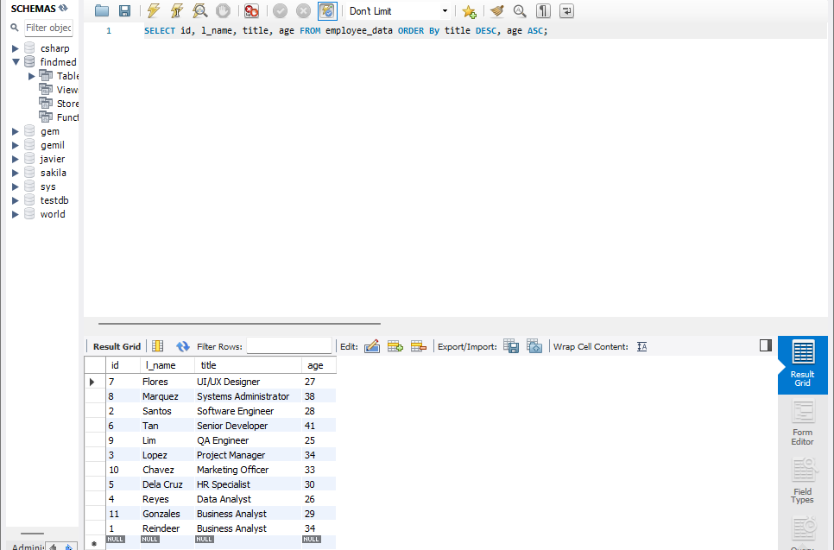
- Display employees(last names followed by first names) who hold the title of either “Programmer” or “web Designer” and sort their last names alphabetically.
SELECT l_name, f_name FROM employee_data WHERE title IN(‘Programmer’, ‘Web Designer’) ORDER BY l_name;

